Legislative rules and voting stability in the Mexican Chamber of Deputies

William B. Heller
Department of Political Science
511 Oldfather Hall
University of Nebraska-Lincoln
Lincoln, NE 68588-0328
tel: 402/472-3216
fax: 402/472-8192
e-mail: wbheller@post.harvard.edu

Jeffrey A. Weldon
Dept. de Ciencias Sociales
Instituto Tecnológico Autónomo de México
Río Hondo 1
Col. Tizapán San Angel
01000 México, DF
tel: (52) 5 628 4000 x3751
fax: (52) 5 628 4078
email: jweldon@smith.rhon.itam.mx

DRAFT

Introduction
The study of social choice suggests that majority rule should be unstable and even chaotic, making reaching agreement on policy difficult and leading to policy outcomes that, taken together, are inconsistent if not contradictory. The solution to the initial puzzle of why the chaos predicted by social-choice analysis is not the normal state of affairs in democratic legislatures is twofold. On the one hand, single-party majorities sidestep the problem, as long as the majority party is disciplined, because the party acts as a unit and the issue of forming majorities is moot. On the other hand, in multiparty legislatures or where party discipline is more in doubt and the problem therefore is more immediate, legislative rules help keep chaos in check. But what if legislative rules are structured to induce instability?

In no legislature that we know of does a bill become law without defeating previously obtaining law. In most legislatures, this key vote that allows a new law to replace the status quo comes at the end of the legislative process. Under this backward agenda process, nothing is final until all amendments are in and the proposed legislation, as amended, wins in a de facto contest against the status quo. The Mexican Congress is not like most legislatures. Rather than the typical backward agenda, both the Chamber of Deputies and the Senate use a form of forward agenda, in which the proposed bill is first paired against the status quo and then subject to amendment—with no final vote pitting the amended bill against the status quo ante. These are rules designed for instability.

The legislative rules in Mexico have always had the potential to lead to chaos. However, up to 1997 in Mexico, one party—the PRI—dominated the legislature. As long as the PRI held a majority, there was no question of instability. When the PRI lost its majority, Mexican deputies discovered that the old ways of doing things no longer worked: the rules were designed for a majority party, to the extent that several important governing bodies of the chamber, such as the collective presidency and political coordination committee (which assigns members to committees and sets the floor agenda), could not be constituted. The legislature’s response to this situation was to rewrite the rules. The new rules, however, seem designed to further induce instability rather than reduce it, by encouraging parties to renege on deals embodied in legislation.

Bills begin in committee and are introduced on the floor only with the signatures of a majority of the relevant committee or when discharged by a two-thirds vote on the floor. At the first reading the bill is debated and voted in its entirety, at which point it becomes the new status quo; after the general bill has been approved legislators can discuss and vote on individual articles or amendments. The problem is that the deals parties make in order to get bills out of committee and approved at the first reading can be picked apart article by article in the second stage. As a result, some of the original beneficiaries of the bill (those who reported it out of committee) might find themselves faced with final legislation that they no longer like but cannot block. The first reading changes the status quo: the second stage defines what the new status quo will look like, and changes are not tested at the end against the original status quo. Change is guaranteed and instability seems inevitable.

What does this mean for legislation? We argue that Mexico’s forward-agenda procedures makes legislating risky. Deals cut in order to build a majority coalition can later be dismantled, article by article and paragraph by paragraph, potentially leading to outcomes that no majority likes. In a backward agenda, the worst that amendments can do is kill a bill; in a forward agenda, the bill survives even if it is worse for everybody than the status quo ante. We look in this paper at recent evidence from the Chamber of Deputies that supports the suspicion that amendments are used to dismantle coalitions.

Without rules beyond a basic decision criterion such as majority rule, legislative control would mean little. A disciplined majority party can function well where rules are few, by substituting party rules and party discipline for legislative process. A majority party without discipline, or a coalition situation with no majority party at all, is different. If there is no solid majority, Condorcet’s paradox comes home to roost: because policy is not naturally unidimensional, in all but the rarest of situations (Plott 1967) any policy that some majority prefers to the reversion (the policy that obtains if no new bill is passed) can be beaten by some other policy that some other majority likes better (cf. Baron and Ferejohn 1989). This is problematic both before and after passage. Before, because it means that legislation passed is likely to be quite different from legislation proposed. Moreover, unless there is a time limit for considering bills it also means that there is no logical end to debate. After, because a newly passed bill establishes a new reversion, which then could be the target of a new bill (McKelvey 1976) extending instability not only to the content of a given bill but across bills as well.

Rules induce stability in two ways. First, the typical requirement that all bills be paired for final passage against the status quo (or some other clearly defined reversion) means that no bill that is worse than the reversion for any majority will pass. Second, breaking a bill into parts and constraining amendments to be germane can set up a structure-induced equilibrium (SIE; Shepsle 1972; Humes 1993; and see Riker 1980). The latter solution requires that legislators accept a suboptimal policy package as the price for stability. As long as some majority prefers the SIE to the reversion, the bill passes. As long as there is some mechanism for holding the majority together (Heller Forthcoming), the bill passes to the benefit of those who proposed it.

What if there is neither a final vote against the status quo nor any good way of holding the majority together? In this paper we examine just such a case—the Mexican Chamber of Deputies. Absent a final vote against the status quo, stability is likely to be ensured by only through SIE. There are two ways to disrupt an SIE through amendments. One is to disallow compromise amendments that can settle at the ideal point of the median voter (for a given dimension). The other is to ensure that policy on each dimension is considered not in isolation but as part of the entire policy package comprised by the bill. The rules in Mexico’s Chamber of Deputies do both.

We proceed in this paper as follows. In Section 2 we focus on forward and backward agendas and the predictability of legislative outcomes. In Section 3, we analyze Mexico’s legislative game as a forward agenda and suggest four hypotheses about how voting on amendments should differ from voting on the entire bill. Section 4 examines voting in the Chamber of Deputies in the context of the hypotheses advanced in Section 2. Section 5 [not yet written] concludes.

Legislative Rules and Legislative Outcomes
Translating societal preferences into policy is no mean undertaking. Citizens express their policy preferences, often crudely, when they choose representatives from among individuals or parties in legislative or executive elections. Those chosen must then make policy.

The principal problem in policy making is aggregating preferences. It would be a rare society in which people were in complete agreement about the goals of policy as well as the best way to achieve those goals. People disagree and as James Madison noted in Federalist 10 any attempt to eliminate disagreement would require the imposition of a common viewpoint. Such an imposition, however achieved, is impossible in a democratic polity. Elections aggregate preferences, but only partially. Policy conflicts persist, to be resolved in the legislature.

How do legislators resolve their policy conflicts? The inevitability of conflict implies that under normal circumstances policy outcomes will depend on policy-making structure and process. Absent a preference-induced equilibrium (analogous to the ideal point of the median voter ; Black 1958; Plott 1967; Shepsle 1987), unstructured policy making is indeterminate—it is impossible to predict either policy outcomes or beneficiaries.

The problem is straightforward. The chances are that that any majority-supported proposal (that is, preferred by some majority to the status quo) that encompasses more than a single policy dimension can be beaten by a different proposal supported by a different majority. Given at least minimally liberal procedures for proposing policy or amendments, this means that legislative outcomes are unpredictable and constrained only by rules governing who can make proposals, what kinds of proposals are admissible, and how it is determined that a proposal is passed into law.

Stopping rules: forward and backward agendas
In most democratic legislatures, the authority to propose new legislation or amendments to legislation under consideration is widespread. Sometimes, the Government or the president of the legislature exercises a gatekeeping function and can block proposals that it does not like (article 74 of the Greek Constitution, for example, permits the Government to reject proposed amendments before they reach the floor). More commonly, however, all legislators have the right both to make proposals (new legislation and amendments) and to defend them on the floor.

When any legislator can propose amendments, how does a legislature ever pass bills? In general, even legislative proposals with majority support are vulnerable to alternative proposals supported by alternative majorities. The problem is twofold. First, if some legislator always can do better—that is, move a policy proposal closer to her ideal point—by amending the legislation on the table to appeal to a new majority, there is no obvious stopping point. Second, absent a non-arbitrary stopping rule and some kind of constraint on proposals there is no way of predicting what the proposal will look like at the end of the amendment process (McKelvey 1976). This would be problematic not only for legislators trying to decide whether to support a proposal but also for potential proposers who would have to wonder whether they might be better off not raising an issue than throwing a proposal into the legislative mill and hoping that what comes out of the process is good enough to have made broaching the subject worthwhile.

Legislatures in the real world of course do pass bills. They do because they have non-arbitrary stopping rules and because in most cases the range of possible outcomes is smaller and more manageable than the entire policy universe. For stopping rules, for example, in the US House the number of allowable amendments might be set in advance by the Rules Committee; in Mexico (and many other countries), the requirement that amendments be offered during article-by-article consideration of a bill (Rules cite***) essentially means that any amendment can cover only a single policy dimension. This provides a natural stopping rule, as deliberation on the bill ends once all articles have been considered.

No matter how clear the rules for deciding when the legislature is finished with a bill, legislators are unlikely to propose new bills if doing so might lead to outcomes that they like less than the result of taking no action. It is important to be able to predict what an amended bill might look like when stopping rules take effect. In most legislatures, a degree of predictability is provided by the simple requirement that there be a final vote pitting the legislation on the table (as amended) against the status quo. This requirement, the defining characteristic of a backward agenda, means that everyone knows that the final outcome will be either the status quo itself or some policy inside the set of all points that are majority preferred to the status quo—that is, the winset of the status quo.

Figure 1 depicts an example of a viable proposal (that is, a proposal that might be passed into law), here labeled x_{0,} given status-quo point x_{q} and using a backward agenda procedure in a legislature of three voters with ideal points at A, B, and C. Adhering to the usual spatial-modeling assumption of symmetrical, Euclidean preferences, each voter likes policy less the further it is from his or her ideal point and is indifferent among all points that are equidistant from that ideal point. The curves labeled I_{A}(x_{q}), I_{B}(x_{q}), and I_{C}(x_{q}) are the voters’ indifference contours with respect to the status quo, and the shaded areas denote the universe of points that some majority prefers to the x_{q}—that is, the winset of x_{q}, W(x_{q}).

The example in Figure 1 highlights one of the key problems of majority rule as well as the defining characteristic of the backward agenda. The problem with majority rule is that there is no obvious reason to choose any one alternative to the status quo over another. A number of plausible assumptions might limit the set of reasonable alternatives to a smaller subset of the winset W(x_{q})—for example, we might expect policy proposals like x₀ to be efficient, so that any alternative to x₀ is worse than x₀ for at least one legislator. For a two-dimensional model like the one in the figure, this implies that alternatives would lie on one of the contract curves between legislator ideal points. Even with this restriction, however, there is usually no a priori reason to expect proposals to lie on a particular contract curve or, much less, at any specific point in the intersection of the contract curve and W(x_{q}).

This problem of indeterminacy in majority rule is not inconsequential. Its effects are constrained, however, in backward agendas. Outcomes might be unpredictable and proposals might cycle from one petal to another of the winset, but they either remain within W(x_{q}) or they do not pass. Whatever strategic calculations go into voting on proposals and alternatives to them, the final vote requires only a sincere evaluation of the proposal on the table versus the status quo. If the proposal is within W(x_{q}), it will pass; if not, it will fail. Backward agendas therefore provide a modicum of certainty: any successful proposal must make some majority better off than it was with the status quo.
Figure 1: Status quo and a viable proposal in a three-voter legislature
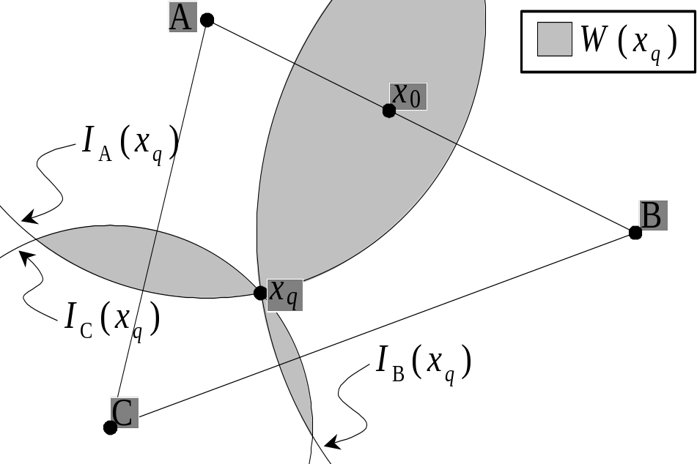

Backward agendas provide a degree of predictability to policy making, but not a lot. The winset of the status quo is generally fairly large, even constraining likely proposals to be efficient. Compared to forward agendas, however, backward agendas are models of stability.

The essential feature of a forward agenda is that there is no final vote against the status quo. Rather, the first vote pits a proposal against the status quo and all subsequent votes are taken not in consideration of what comes next but of what came before. In essence, the status quo changes with every successful vote. Using a backward agenda, legislators evaluate any amendments to x₀ in Figure 1 in terms of their preferences for the original proposal and the proposal as amended and their preferences for the amended proposal and the status quo. Using a forward agenda, once x₀ is approved x_{q} becomes irrelevant and a successful proposal simply must lie within the winset of x₀.

An example of how offers can move policy using a forward agenda is shown in Figure 2. Here, with ideal points and status quo as in Figure 1, every approved proposal replaces the status quo—that is, becomes the new status quo—and the status quo ante becomes irrelevant. If inefficient proposals are likely, as for example if the proposer is not one of the voting legislators, then the final outcome could be anywhere in the policy space (McKelvey 1976). If reasonable proposals are efficient (like x₀ and x₁ in Figure 2), then the outcome could be any point on the Pareto hull (that is, on the AB, AC, or BC contract curves in Figure 2). In the figure, x₀ is majority preferred to x_{q}, and x₁ is majority preferred to x₀; in a sequential voting procedure using a forward agenda (and stopping after the second round of balloting), x₁ would be the outcome even though no majority prefers it to the status quo.
Figure 2: Status quo and sequential offers using a forward agenda
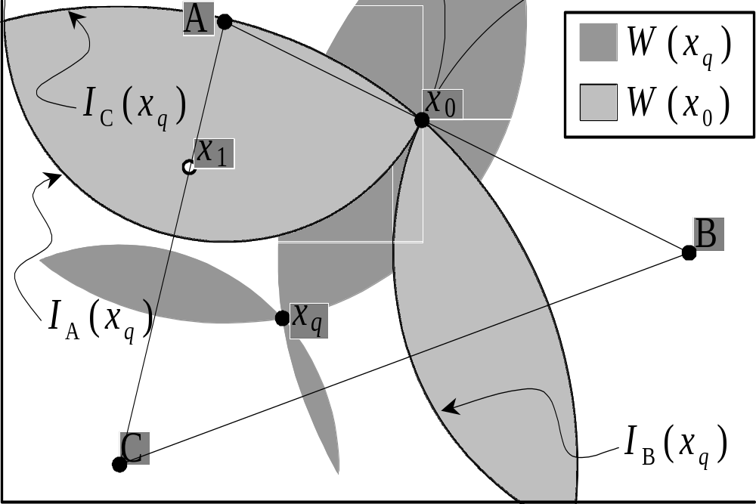
The fundamental difference between backward and forward agendas is the constraints they impose on viable offers. In a backward agenda, any viable offer must be majority preferred to the status quo; any viable alternative offer must be majority preferred both to the status quo and to the proposal it is intended to replace. Strategic proposers can design their initial offers so that the range of counterproposals that beat both it and the status quo is limited—or, as in the case illustrated in Figure 1, nonexistent. This is impossible using a forward agenda, however. Any proposal that does not meet the Plott (1967) conditions for a multidimensional median can be beaten by some other proposal, and once a proposal passes whatever it replaced becomes irrelevant.

Agenda processes differ across countries (Rasch 2000) and, as in the US House of Representatives where the process can vary with every bill if the Rules Committee so desires, sometimes even within countries (Oleszek 1996), 144-150. One rule holds firm almost everywhere, however: at the end of the day the process ends and the proposal on the table goes up against the status quo. If a majority prefers it to the status quo, it passes; if not, not.

The rules of procedure in Mexico’s Chamber of Deputies provide an exception to this rule. In Mexico, as in many countries, the first reading of a bill establishes whether the legislature will debate it or consign it to the trash heap of unsuccessful legislation. In Mexico, unlike any other country of which we are aware, after that first reading the Chamber of Deputies does not revisit the bill as a whole. Proposals approved at the first reading are debated (and amended) article by article, and once the last article is debated and voted—up or down, amended or not—the bill is passed. We now turn to examine this process—essentially a forward agenda, albeit with some constraints—and its implications in more detail.

A sketch of legislative process in the Mexican Chamber of Deputies
Figure 3 outlines the procedure for considering legislative proposals in the Mexican Chamber of Deputies, as set out in article 71 of the Constitution (which states who has the power to present bills), article 72 of the Constitution (which details the nature of the bicameral process and the executive veto), the Ley Orgánica (which mostly deals with the organization of the chambers), and the Reglamento (where nearly all of the legislative procedures are detailed). Both the Ley Orgánica and the Reglamento serve for both of the chambers, and the procedures are identical. There is also a parliamentary agreement (acuerdo parlamentario), published in November 1997, that covers specific rules of debate and amendment.
The Reglamento requires all bills to be sent to one or more committees for a report (Reg., arts. 56, 60). Bills may be considered directly on the floor only if the members agree to suspend the rules if the bill is considered to be of obvious or urgent resolution (Reg., art. 59). Suspending the rules to skip the committee process requires a two-thirds vote. This procedure can also be used as a last resort to discharge a bill from committee. Parties’ representation in committees is proportional to their strength on the floor (LOC, art. 43), so committee composition reflects that of the floor.
Committees take decisions by majority rule and may amend bills without restriction. Committee amendments are automatically incorporated in the bill, and floor consideration begins with the committee report rather than the original bill. The marked-up committee version of a bill—the Committee Report—must be signed by a majority of committee members (Reg., art. 88) and reported to the floor in a separate vote. (AP 12/97, art. 6). Dissenting members of a committee may file a minority report (Reg., art. 88), which can only be taken up on the floor if the chamber rejects the original majority report (Reg., art. 119).
All bills, except those with only one article, are debated in two stages, en lo general and en lo particular (Reg., art. 97). The vote en lo general pits the Committee Report (as amended during consideration en lo general) against the status quo (Reg., art. 117). Debate en lo particular deals with individual articles or sections of articles in the order they appear in the bill and amounts to a dimension-by-dimension examination of the bill. Amendments are in order during debate en lo general and usually are subject to a nonrecorded division (standing) vote. Moreover, deputies can request that specific articles be reserved for debate and vote en lo particular. This second stage provides opportunities for more detailed consideration of articles and more chances to amend the committee bill. In an unusual departure from usual legislative procedure, there is no provision in the Reglamento for a final reading pitting the bill as amended en lo particular against the status quo.
Rules governing amendments in the Mexican Congress are confusing and contradictory. The only formal rules governing floor amendment procedures are articles 124 and 125 of the Reglamento. Article 124 appears to prohibit amendments during debate: “In the session in which a proposal or bill is definitively voted on, additions or modifications to the approved articles can be presented in writing.” If amendments are restricted to articles already approved, then no amendments can be offered during debate en lo general because no article has been approved yet. No amendment can be offered during debate en lo particular, because only articles that were not approved en lo general can be discussed en lo particular. There is no time scheduled for debate on an article after it has been approved. (The chamber rarely invokes this rule. In December 2000, however, there was an attempt to use it in the Senate to prohibit a floor amendment.)
Figure 3: Chamber of Deputies Amendment Process,
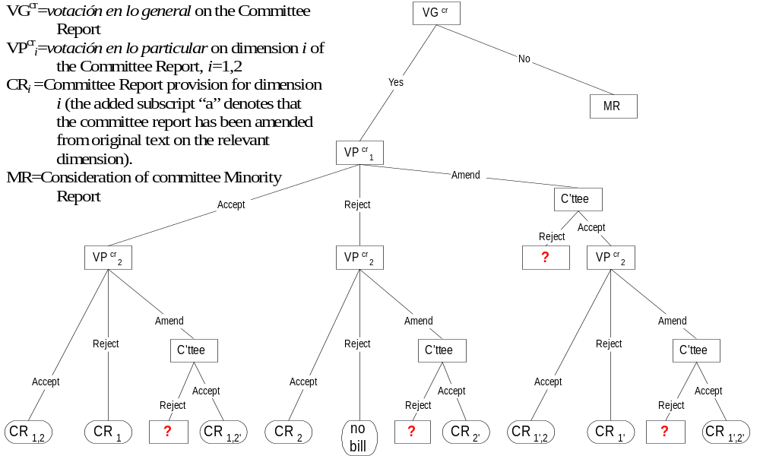
Article 125 is less restrictive, allowing votes on amendments, which if approved are then sent to the relevant committees for consideration. Therefore, the floor does not technically vote on the amendment, but only on whether to send the amendment to committee for a new report. Committees do not appear to be bound by these floor votes, though any decision taken in committee in this respect will be reviewed again on the floor. These rules give the committee a veto over any amendments to its own report. In essence, then, Committee Reports are considered on the floor under a nearly closed rule. The one significant caveat is that the rule is closed on an article-by-article basis, but the floor can strike individual articles without rejecting the entire bill.
In sum, there are two ways to amend committee reports in the Chamber of Deputies. First, floor amendments can be offered during debate en lo general or en lo particular, voted on by a division vote. Reporting committees appear to have a veto over these amendments unless the modification was adopted under a suspension of the rules. Amendments that succeed on the floor therefore likely enjoy overwhelming support or at least the support of a floor majority that is reflected in committee composition. Second, articles can be deleted en lo particular, voted in a nominal vote. This option is always available but potentially carries a high cost. The danger is that agreements reached in committee to build majority support for a bill en lo general might be undone by deletions en lo particular.
In the final analysis, every article or subsection of an article that is reserved for votación en lo particular can take one of three forms. It can be deleted, it can be accepted, or it can be amended. The issue of amendments complicates the procedure and possible outcomes severely, so for present purposes we focus only on the choice of whether to accept or reject. The first question to ask is what happens when an item goes down to defeat in the votación en lo particular—that is, what is the reversion for any given vote? Legislative rules offer little guidance here, but it seems most plausible that the reversion on any given dimension is that dimension’s status quo ante.

Interpreting Mexico’s Legislative Game
We begin with the maintained hypothesis that any Committee Report passed in votación en lo general must be majority preferred to the status quo. Together with our assumption that legislators seek efficient bargains and the constraint that each votación en lo particular is a binary choice between accepting an article or deleting it from the Committee Report, this means that passage of a Committee Report defines the set of possible outcomes depending on whether and how much is changed in the votaciones en lo particular. Figure 4 and Figure 5 show two examples of how passing the Committee Report, labeled x₀, defines the available alternatives.

In both figures the Committee Report is a bill with two articles, each on a different policy dimension. The points marked x₁ and x₂ represent the policy outcome if the Committee Report is stripped of the first or second article, respectively (but not both). Even though a majority prefers x₂ to x₁, since votaciones en lo particular are taken in the order that reserved items appear in the Committee Report, the former is reachable only if the legislature does not amend the Committee Report to x₁ by deleting the first article. Once x₁ is reached, the only possibility left in both examples is to eliminate the remaining article and return to the status quo ante.

In Figure 4, a majority prefers x_{q} to x₁, x₁ to x₀, and x₀ to x_{q}. Group preferences are intransitive, and absent some method of committing legislators to support the Committee Report even in the face of alternatives they prefer to it the likely result of introducing a bill like x₀ in Figure 4 would be to churn through the available alternatives and eventually end up with the status quo ante. One might wonder, if this is a likely scenario, why anyone would bother introducing legislation at all. The problem is twofold. First, one majority prefers x₁ to x₀ and a different majority prefers x₂ to x₀. Second, some majority prefers x_{q} to both x₁ and x₂. Since a majority prefers x_{q} to x₁, it is easy to see why the second article would be deleted as well, effectively yielding reversionary policy on both dimensions. Once at x₁, those who dislike the amended Committee Report at least retain the possibility of protecting themselves by stripping the remainder of the bill; no such protection is available at x₂, by contrast, as voting ends after consideration of the second article.

Figure 5 is similar to Figure 4 but with a slightly less centrist status quo. In this figure, there is no cycle: x₀ is preferred to x_{q} and x₁ is preferred to x₀—and also to x_{q}. Both x₁ and x₀ also are majority preferred to x₂. Should a majority in this case choose to stick with x₀ rather than amend the Committee Report to x₁, they need not worry about ending up with x₂ instead. It is easily predictable that a Committee Report of x₀ would easily be amended to x₁, which would be the final outcome. In this case, of course, it is hard to see why the committee would report x₀ rather than x₁ in the first place. Depending on the location of the status quo and the Committee Report, it is of course certainly possible that neither x₁ nor x₂ are majority preferred to either x₀ or the status quo. Such bills pose no problem for the simple case where votación en lo particular entails only a choice between accepting and rejecting each article. We suspect that many bills are more problematic, however, even if we restrict amendment activity to a binary choice.
Figure 4: Forward Agenda, Accept or Reject by Article, Reversion in Top Cycle
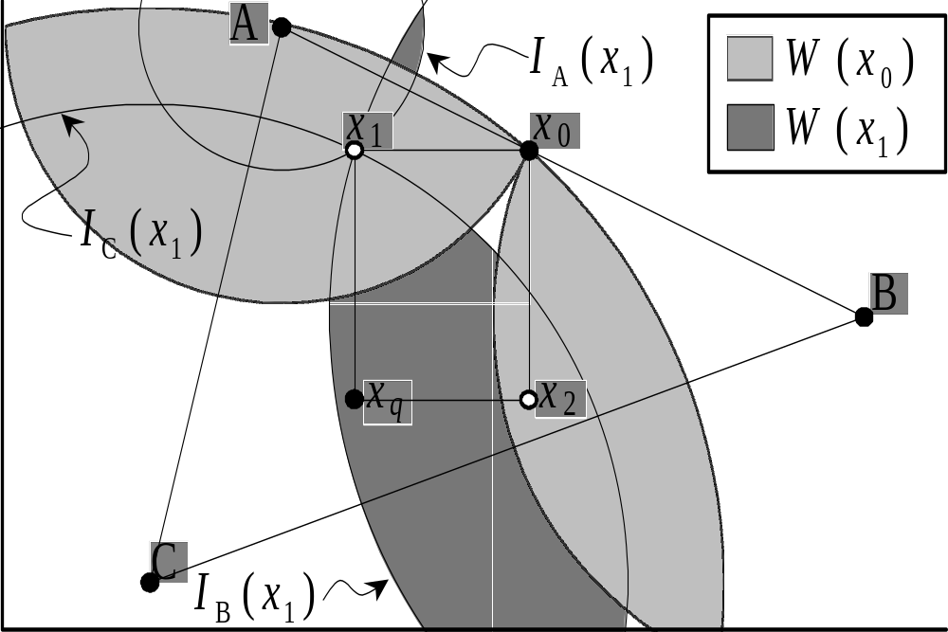
When article-by-article consideration of a bill is limited to passing or rejecting articles sequentially in the order they appear in the bill, outcomes are in principle predictable. Unconstrained forward agendas, where amendments are allowed and germaneness is not a consideration, are unpredictable as long as agenda authority is dispersed. (If proposal authority is available only to a limited set of actors, outcomes predictably will favor those so privileged; cf. McKelvey 1976.) The Mexican process gives pride of place to the committee that reports a bill, but anybody can reserve articles for votación en lo particular on the floor. This process yields a degree of predictability—or perhaps a sort of controlled chaos—and implies one of two things. Either a) committees will exercise negative agenda control (Cox and McCubbins 1999; Campbell, et al. 2000) and simply not report bills that are likely to yield outcomes that a committee majority likes less than the status quo; or b) those who support the original Committee Report will figure out ways to bind themselves to it and so preclude the nocent effects of competing majorities and a shifting status quo.

How might the supporters of a bill commit themselves to vote against an alternative that they prefer to it? One answer is packaging. Most legislation comprises some combination of policy dimensions. Someone who prefers the entire package to the status quo might well dislike some of the dimension-specific policies included in it. The problem with article-by-article consideration of the bill is that it makes it possible to strip away pieces that garner little support individually but that are crucial for ensuring that some majority prefers the bill as a whole is to the status quo ante. The problem with article-by-article consideration under a forward agenda is that the result of stripping articles from bills can yield outcomes that most players like less than no bill at all.
Figure 5: Forward Agenda, Accept or Reject by Article, Reversion not in Top Cycle
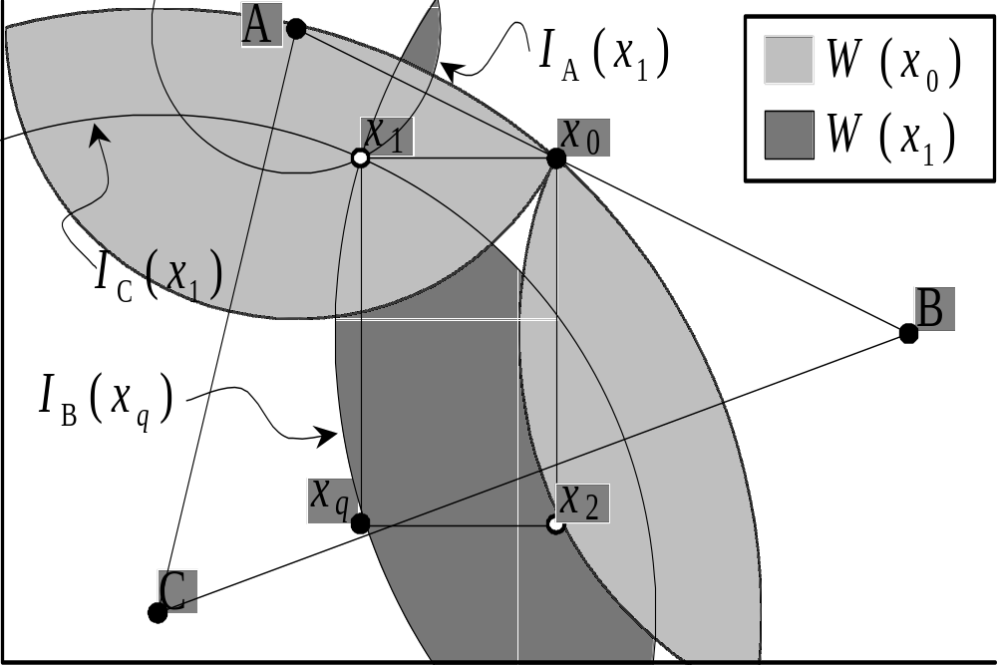

One possible solution to this problem is repeat play. Single bills come and go while the legislators voting on them remain, so legislators can make their own continued cooperation contingent on the continued cooperation of their colleagues. An alternative (and complementary) solution is structure bills—recall that articles are considered in the order they appear—so that the articles most likely to be deleted are the first to be considered, allowing their supporters to hold later articles hostage to them. The simplest example of this would be to consider the enacting clause last, which would be equivalent to a final vote against the status quo. In either case, binding is unlikely to be complete: some legislators will focus more on the question on the table rather than the prospects for cooperation on future questions; some legislators will vote against specific articles, perhaps expecting enough others to support it so that it will pass anyway or perhaps disbelieving threats of retribution; and some legislators (like voter C in Figure 5) might prefer any stripped-down version of the bill—or no bill—to the Committee Report.

In the final analysis, each votación en lo particular is a vote for an alternative to the Committee Report (as amended by each preceding votación en lo particular). The lack of a final vote pitting the amended Committee Report against the status quo suggests that voting patterns might differ greatly between the votación en lo general and subsequent votaciones en lo particular. We now turn to characterize what we expect to see and why it should be different from voting under a backward agenda.

Hypotheses
If policy bargains are in some sense efficient, then the various components of a bill are included at the behest of one or another of the members of the coalition supporting it. Changing or deleting parts of a bill might make some legislators, better off, even among legislators who support the original bill, but it also is damaging to other erstwhile supporters. This means that the set of legislators who vote to amend (including deleting parts of) a bill should be different from the set of legislators who originally voted for the bill. This would be expected under a backward as well as a forward agenda, of course: where forward agendas differ from backward ones is not in the dynamics of amendment processes but in the predicted results thereof. This difference leads us to expect different behavior when voting on amendments under one set of rules than another.

We cannot directly compare amending activity under the Mexican rules to a backward agenda. Instead we begin, as in Section 2.2 above, by suggesting four hypotheses with respect to amendments in the form of deletions from a bill and endeavor to suggest how observations might differ under a backward agenda. We do not here examine amendments in the form of substitutes, as the de facto committee veto on other kinds of amendments complicates the analysis.

Our first hypothesis is that the number of parties supporting a bill en lo general should be greater than those supporting deletions en lo particular. This follows from the first hypothesis: as long as parties remain cohesive, then the only way to make a coalition smaller is to take parties out of it. One implication of this is that such deletions should be less likely to pass in general: to the extent that the original coalitions are minimum winning, stripping away members from them turns them into minorities. This hypothesis does not differentiate between forward and backward agendas.

Our second hypothesis is that votos en lo particular should be closer than votos en lo general. The reason for this is straightforward and depends first on the observation that in Mexico there is neither an enduring majority coalition nor is there an obvious reason (such as the allocation of cabinet portfolios in parliamentary systems) for one to exist. Second, given the assumption that bills are efficient, deleting articles or sections of articles is likely to erode overall support for the bill without attracting new support. After all, any supporters added in such a manner might more profitably have been brought into the bill’s supporting coalition from the outset. Hence, each new amendment pares down the bill and strips away supporters. (One caveat to this prediction is that if many reserved items are defeated en lo particular it might make sense for the coalitions stripping away later reserved items to grow. As initial deletions move a bill away from its original supporters and make them worse off than they were without the bill at all, later deletions might actually serve to bring the bill back closer to the status quo ante.)

Under a backward agenda, by contrast, it is hard to imagine that reserved amendments would ever pass. To the extent that deleting amendments makes a bill less desirable than the status quo, the requirement that the bill as amended be voted against the status quo at the end of the process should be enough to keep most such amendments from passing. Amendments that do pass are likely either to be designed to change the composition but not the size of a bill’s support coalition or to be perfecting amendments designed to make the bill better. There is therefore no reason to expect smaller coalitions for successful amendments under a backward agenda. Different, possibly, but not smaller. The key difference here between forward and backward agendas is the likelihood of passage, particularly when the question is whether to delete an article outright rather than amend it: no majority prefers x₁ in Figure 4 to the status quo ante, for example, and so while a motion to delete the first article (and so move to x₁) would pass under a forward agenda it would not pass under a backward agenda.

What if parties are not necessarily cohesive? In the real world, party members’ preferences probably are generally be closer to those of most of their copartisans than to most members of any other party, but they are not identical. To the extent that party members are not bound by iron discipline, then our first hypothesis suggests that deleting articles might strip away not parties but individuals. This leads us directly to our fourth hypothesis. If votos en lo particular strip parties away from the original majority coalition or individuals away from their parties, then it follows that any measure of voting likeness between parties that supported the bill en lo general should decrease. We turn now to put these hypotheses to the test against evidence from voting en lo general and en lo particular in the Mexican Chamber of Deputies.

Bills and votes
Electronic voting has been used in the Chamber of Deputies since October 1998. The roll call votes used for the 57th Legislature comes from several sources, including the Gaceta Parlamentaria, which is available on internet. The Gaceta so far has not published votes en lo particular for the 58th Legislature, so detailed analysis of votes in the current Congress is not yet possible.
We focus only on bills that were voted on en lo particular or for which amendments were voted with the electronic machines are included in the analysis. Most bills are not considered en lo particular, because no one reserves any articles, and there is one final vote for passage both en lo general and en lo particular. Most important bills have at least one article reserved, however. For example, the budget, the revenue law, the new Ley Orgánica of Congress, the bank bailout law, and some major judicial reforms all had some votes en lo particular.
A total of 19 bills had additional votes beyond the vote en lo general. There were 79 votes en lo particular for these bills, and additionally 13 votes on amendments (which could happen en lo general, en lo particular, or as a substitute if the original committee report was defeated). Most votes on floor amendments were by standing division, so they are not included in the analysis.

Voting scores
In order to address our hypotheses about voting under a backward agenda, it is important to define our terms. Unless party cohesion is complete at all times, it might be difficult to say when a party had peeled away from a coalition, for example. Before examining the evidence for the effects of a forward agenda, therefore, we here provide a brief discussion of our measures.
The standard party cohesion scores usually measure a dichotomous vote. For example, the most common cohesion score, the Rice (1928) index, measures the absolute difference between the pro and con votes for party_{i}:
I_{i} = | %yes_{i} - %no_{i} |
The index runs from 0 (when the party splits 50-50) to 100 (when all members vote on the same side).
The Rice index does not consider abstentions. However, in Mexico, only a plurality of votes in favor is necessary to approve bills, if at least half of the Chamber has voted.
However, abstentions are very common in the Mexican Congress. For the period studied, the average total for any roll call is 412, of which on average 13 members abstain. There were 20 votes in which there were at least 20 abstentions, 10 cases in which there were at least 50 abstentions, and twice over 100 abstentions. In 18 occasions in the sample of votes available from the 57th Legislature, the largest vote share for a party is abstention. A plurality of the PRD voted in abstention on seven votes. A plurality of panistas voted in abstention once. Therefore, abstentions are significant in the Chamber of Deputies and should be included in any cohesion score.
We therefore propose that for trichotomous votes, the cohesion index (I³) be the maximum of the yeas, abstentions, and nays, divided by the total number of members voting in party_{i} (see Weldon 2000):
I³_{i} = max (%yes_{i}, %abs_{i}, %no_{i})
This index is usually higher than the Rice index, because it measures the highest proportion rather than the difference between proportions. The score ranges from 33.3 to 100. In the former case, a party was evenly divided among members in favor, against, and abstaining; in the latter, all members voted in the same direction.
Nonvoting members are excluded from this analysis. It is difficult to identify in the Chamber of Deputies whether an absence was justified, accidental, or intentional.
We measure voting patterns among parties by a modified version of the Rice (1928) voting likeness score. The definition of the Rice voting likeness index between party_{i} and party_{j} is as follows:
IVL = 1 - | %yes_{i} - %yes_{j} |
This index runs from 0 (when all of the members of one party vote against all of the members of the other party) to 1 (when the same proportion of each party vote in the same sense, whether this be all in favor, 62 percent of each party in favor, or 2 percent of each party in favor, etc.). The Rice IVL does not consider abstentions, so it must be modified for use in the Mexican Chamber of Deputies. We suggest a trichotomous voting likeness index proposed in Weldon (2000) based on the Loosemore-Hanby (1971) index of proportionality (D). This index is usually used to measure the proportionality of electoral systems. The formula for Loosemore and Hanby’s D index is:
D = (Σ | V_{i} – S_{i} | )/2
In the formula, V_{i} is the proportion of the total vote for party_{i}, and S_{i} is the proportion of seats for that party. If D is zero, then the system is perfectly proportional.
These two indices can be combined to create a trichotomous voting likeness index between party_{i} and party_{j}:
IVL³ = 1 – (| %yes_{i} - %yes_{j} | + | %abs_{i} - %abs_{j} | + | % no_{i} - % no_{j} | )/2
The IVL³ index runs from 0 when the two parties totally disagree on a vote (regardless of whether the disagreement be expressed in votes in favor, against, or abstentions), to 1 when the two parties agree in exactly the same sense. This index is overly sensitive to one or two dissenting votes from the very small parties, just as the cohesion index tends to punish a small party heavily for a few disagreements.

Hypotheses and evidence
We are now ready to hold our hypotheses up to the light of the evidence. To reiterate, we claim first that voting en lo particular should break coalitions down—rather than reinforce them, as we would expect for example of perfecting amendments in a backward agenda. Second, breaking coalitions down does not imply replacing them with alternative coalitions, but rather only that support for amendments en lo particular should be lower than en lo general support for the original bill. Third and related to our second hypothesis, votes should be closer en lo particular than en lo general; and finally, voting likeness between parties that vote together en lo general should decrease as well. More generally, Mexico’s forward-agenda procedures lead us to expect to see attempts to break up enacting coalitions. Our claim that there is no mechanism to hold coalitions together (as there is in a parliamentary system, provided by the structure of government; Epstein 1967) implies that amendments can pass even though they eat into the coalition or make the bill worse overall.

Sometimes voting en lo particular successfully removes articles. Of the 79 votes en lo particular in the 57th Legislature, two were successful in deleting articles. These were two items in the reforms to the Fiscal Coordination Law, which deals with revenue sharing with the states. The bill had the support of all five parties en lo general (December 14, 1999), but the PRI and PT joined together to remove the paragraphs in question.

There were 19 votes en lo particular in the first months of the 58th Legislature, one of which successfully deleted part of the approved bill. On December 21, 2000, all eight parties supported the bill that reformed the Customs Law en lo general, but six parties, led by the PRI and the PRD (which together have a majority) removed one of the articles.
It is worth noting that voting en lo particular is rare in the Senate and has happened only seven times so far in the 58th Legislature. However, on two occasions the proposed deletions were successful. On December 28, 2000, the Senate approved the Omnibus Tax Bill (Miscelánea Fiscal) by a vote of 108 to 0 with 3 abstentions. The bill had already been approved by the Chamber of Deputies. Then the Senate voted to delete three articles from the tax code by two votes. Although the votes are not available, it is known that the PRI and PRD voted to delete the articles while the PAN voted to maintain them. The bill had to be sent back to the Chamber of Deputies so that the lower house could approve the changes.
Having established that votos en lo particular do occur and on occasion matter, we turn now to the evidence for each hypothesei.

Coalitions break down en lo particular.
The coalitions that we measure here are the winning coalitions, regardless of whether the vote was in favor or against. Most of the bills under consideration had strong support in committee and en lo general. There were five parties in the Chamber of Deputies in the 57th Legislature, and 10 of the 19 bills were supported by at least a plurality of the members of all five parties. The mean number of parties supporting the 19 bills studied was 4. However, the mean number of parties decreased to 3 in voting en lo particular. On average, at least one party voted for the bill in general, but voted against a particular article. In no cases were there more parties in the winning coalition in a vote en lo particular compared to the vote for the same bill en lo general. Of the 79 votes en lo particular, 67 included fewer parties in the winning coalition than had been supporting the bill en lo general. This is strong evidence that whole parties abandon the oversized coalition that created the bill, rather than just some few members who do not favor some particular articles.

The margin of victory decreases en lo particular.
Margin is measured simply by number of votes in favor minus the number of votes against. Here the evidence is clear, as well. In 76 of the 79 cases (95 percent), the margin decreased in the votes en lo particular (including the two cases where the margin was negative and the articles were deleted). In only three cases were the margins wider en lo particular. Excluding two of the 19 bills that had no votes en lo particular (they only had amendments with roll calls, and one of the two was actually defeated on the floor), the mean margin of victory en lo general of the 17 bills was 359 votes. The mean margin of victory en lo particular was 176, still a good margin in a chamber of 500 members, but half the size of the mean of the main vote on the bill against the status quo.
For the FY 2000 budget (voted on December 28, 1999), there were nine votes en lo particular in which the PRI reserved articles, and voted against, while the other four parties voted in favor. The margin of victory in maintaining these articles in the bill was between one and nine votes. There were also three very close amendments on that budget, in which the PRI prevailed by one vote in favor to accept its substitute amendment (raising the level of expenditures on the bank bailout), and defeating an amendment by the PAN to decrease spending on the same item, also by one vote. In a later vote on the budget, an amendment from the PRI to spend more money on pensions was defeated by a margin of three votes.
The FY 2000 budget is an excellent example of the possible chaos in voting en lo particular. The five parties were in agreement on most of the questions, except the bank bailout and some increased expenditures for partisan constituencies. They could not come to an agreement to get the bill out of committee for some time. The bill on its first attempt (December 21, 1999) was defeated on the floor by a margin of 245 to 248 (the PRI and PT voting against). The PRI’s substitute bill, considered after the committee bill was defeated, led first to a 246-246 tie, and then to a 247-248 defeat. In both cases, a majority of the PT also voted against, but this time against the PRI.
The parties decided later to report the bill and support it en lo general on December 28. The vote en lo general was 465 to 8 with 10 abstentions. The rules had been suspended to bring up substitute amendments without having to first defeat the committee report. This led to the very close votes described in the previous paragraph. Had the PT abandoned the opposition coalition on any of those votes, then the budget agreed to by consensus by all parties would have been mutilated, and there would have been no recourse for the PAN and PRD.

Voting likeness decreases.
Voting likeness combines two other measures in one statistic: interparty coalitions and intraparty discipline. If coalitions break up, the voting likeness between those two parties decreases. If two parties remain in a coalition, but one of the parties has lower cohesion, then voting likeness will also decrease.
Table 1
Mean Voting Likeness
Chamber of Deputies
57th Legislature (1998-2000)
(in percentages, 19 votes en lo general,
79 en lo particular, 13 amendments)
Party | Votes  en lo  general |  | Votes  en lo  particular |  | Votes en lo  particular  & Amendments
 | Mean | S.D. | Mean | S.D. | Mean | S.D.
PAN-PRD | 69.7 | 38.9 | 34.2 | 40.3 | 38.5 | 41.7
PRI-PAN | 87.4 | 26.5 | 69.2 | 41.0 | 67.1 | 42.1
PRI-PRD | 67.9 | 40.9 | 15.6 | 29.6 | 17.7 | 32.1

Table 1 demonstrates that the PRI and the PAN usually vote together on bills en lo general, with an IVL³ score of over 87 percent. The PRD shares with the other two parties an IVL³ score nearly 20 points lower en lo general, which indicates that sometimes, but not often, the PRD votes against a bill in general, or that a number of perredistas vote against the bill. There are impressive differences, however, when we consider the 79 votes en lo particular on the same bills. The score for the voting likeness between the PRI and the PAN decreases from 87 percent to 69 percent. In other words, the PAN on occasion voted against en lo particular or a number of panistas voted against. The IVL³ score between the PAN and the PRD decreases by half, from about 70 percent to 34 percent, but the most dramatic decrease is between the PRI and the PRD, which falls from 68 percent to about 16 percent. Clearly, the PRD splits away from the winning coalition when it votes en lo particular. However, there is evidence here that the PRD also shaves votes away from the PAN, because the PAN-PRD score does not fall so dramatically as the PRI-PRD score.
Table 2
Changes in Voting Likeness
Chamber of Deputies
57th Legislature (1998-2000)
(in percentages, 19 votes en lo general,
79 en lo particular, 13 amendments)
 | Votes en lo particular |  |  |  | Votes en lo particular  and Amendments
Parties | Decrease | No  Change | Increase | Total | Decrease | No  Change | Increase | Total
PRI-PAN | 77.2 | 8.9 | 13.9 | 100 | 73.9 | 9.8 | 16.3 | 100
PRI-PRD | 81.0 | 13.9 | 5.1 | 100 | 76.1 | 14.1 | 9.8 | 100
PAN-PRD | 63.3 | 10.1 | 26.6 | 100 | 58.7 | 9.8 | 31.5 | 100

In Table 2 we find that the voting likeness among the parties nearly always decreases. For example, in 64 out of 79 votes, the voting likeness between the PRI and the PRD decreases from the level on the same bill en lo general. Only on four occasions did it increase. We find more evidence here that the PRD and the PAN sometimes cooperate en lo particular, because on 21 votes out of 79, the voting likeness between the two (then) opposition parties increased. If we consider votes en lo particular and amendments, there were 29 out of 92 votes in which the two parties voted more similarly than en lo general.

Discussion: Cohesion decreases for the PAN, but increases for the PRD.
Party cohesion changes in very different ways for the three parties. Cohesion for the three parties was very high throughout the 57th Legislature. On 120 public bills, the mean cohesion (measured by I³, described above) of the PRI was 99.5 percent. The PAN had cohesion levels of 93.2 percent, and the perredistas voted together by an average of 92.1 percent. The mean cohesion for the 19 bills that had votes en lo particular or amendments is in Table 3.
Table 3
Mean Party Cohesion
Chamber of Deputies
57th Legislature (1998-2000)
(in percentages, 19 votes en lo general,
79 en lo particular, 13 amendments)
Party | Votes en lo  general |  | Votes en lo  particular |  | Votes en lo  particular  & Amendments
 | Mean | S.D. | Mean | S.D. | Mean | S.D.
PAN | 95.3 | 6.7 | 93.7 | 11.3 | 93.6 | 11.3
PRD | 93.8 | 6.8 | 92.5 | 12.8 | 93.0 | 12.4
PRI | 99.9 | 0.3 | 99.9 | 0.3 | 99.8 | 1.1
All | 96.3 | 6.1 | 95.3 | 10.4 | 95.4 | 10.2

The internal cohesion for each of the parties increases on these important bills, with the PRI at 99.9 percent. We also find that the mean cohesion for both the PAN and the PRD decrease a point or two when they vote en lo particular or on amendments.
Table 4
Changes in Party Cohesion
Chamber of Deputies
57th Legislature (1998-2000)
(in percentages, 19 votes en lo general,
79 en lo particular, 13 amendments)
Party | Votes en lo particular |  |  |  | Votes en lo particular  and Amendments
 | Decrease | No  Change | Increase | Total | Decrease | No  Change | Increase | Total
PRI | 19.0 | 72.2 | 8.9 | 100 | 17.4 | 75.0 | 7.6 | 100
PAN | 58.2 | 11.4 | 30.4 | 100 | 54.3 | 12.0 | 33.7 | 100
PRD | 25.3 | 12.7 | 62.0 | 100 | 23.9 | 14.1 | 62.0 | 100

Table 4 presents the changes in cohesion for each party on each vote en lo particular compared to the vote on the same bill en lo general. Here we note important differences for the three parties. The cohesion for the PRI remained the same (usually 100 percent) on 57 of the 79 votes en lo particular, and increased on another 7 votes.
The PRD cohesion increased on votes en lo particular on 49 out of 79 occasions. This is probably due to the PRD’s using votes en lo particular for position taking. For the PRD, votes en lo general are difficult because they split the party somewhat. But the party can rally together and vote to establish the party’s program in votes en lo particular which are unlikely to be approved.
On 46 of the 79 votes en lo particular (58 percent of the time), the cohesion for the PAN decreased, indicating that frequently panistas split off from their party to support either the PRD (usually in an attempt to delete an article) or with the PRI (to sustain an article). The PAN was able to maintain discipline on votes en lo general, but its cohesion was challenged more frequently on the article-by-article votes.
The roll calls en lo particular are not available for the 58th Legislature, but we should expect somewhat different results party cohesion. Cohesion is stronger for parties in government in Mexico (it has increased from about 93 percent to about 97 percent for the PAN, and decreased from over 99 percent to about 96 percent for the PRI). So it is more likely that cohesion will remain the same or increase on votes en lo particular for panistas in the current legislature. The priísta deputies are more likely to suffer splits en lo particular today, as some will want to follow the lead of the PRD in deleting articles, while other are likely to remain with the bills as approved en lo general. The pattern of cohesion for the PRD should not change much.

Conclusion

References

Baron, David P., and John A. Ferejohn. 1989. “Bargaining in Legislatures.” American Political Science Review 83(4):1181-1206.
Black, Duncan. 1958. The Theory of Committees and Elections. Cambridge: Cambridge University Press.
Campbell, Andrea C., Gary W. Cox, and Mathew D. McCubbins. 2000. "Agenda Power in the U.S. Senate, 1877 to 1999." Manuscript. University of California, San Diego, La Jolla, Calif.,
Cox, Gary W., and Mathew D. McCubbins. 1999. "Agenda Power in the U.S. House of Representatives, 1877 to 1986." Stanford University Prepared for delivery at a Conference on the History of Congress, Stanford, California,
Epstein, Leon D. 1967. Political Parties in Western Democracies. New York: Praeger.
Heller, William B. Forthcoming. “Making Policy Stick: Why the Government Gets What It Wants in Multiparty Parliaments.” American Journal of Political Science.
Humes, Brian D. 1993. “Majority Rule Outcomes and the Choice of Germaneness Rules.” Public Choice 75:301-316.
Loosemore, John, and Victor J. Hanby. 1971. “The theoretical limits of maximum distortion: some analytic expressions for electoral systems.” British Journal of Political Science 1:467-477.
McKelvey, Richard D. 1976. “Intransitivities in Multidimensional Voting Models and Some Implications for Agenda Control.” Journal of Economic Theory 12:472-482.
Oleszek, Walter J. 1996. Congressional Procedures and the Policy Process. 4th ed. Washington, DC: CQ Press.
Plott, Charles. 1967. “A Notion of Equilibrium and Its Possibility under Majority Rule.” American Economic Review 57:787-806.
Rasch, Bjørn Eric. 2000. “Parliamentary Floor Voting Procedures and Agenda Setting in Europe.” Legislative Studies Quarterly 25:3-23.
Raunio, Tapio. 1999. "The Challenge of Diversity: Party Cohesion in the European Parliament." In Party Discipline and Parliamentary Government, ed. Shaun Bowler, David M. Farrell, and Richard S. Katz. Columbus, Ohio: Ohio State University Press.
Rice, Stewart A. 1928. Quantitative Methods in Politics. New York: Alfred A. Knopf.
Riker, William H. 1980. “Implications from the Disequilibrium of Majority Rule for the Study of Institutions.” American Political Science Review 74(2):432-446.
Shepsle, Kenneth A. 1972. “The Strategy of Ambiguity: Uncertainty and Electoral Competition.” American Political Science Review 66(2):555-568.
Shepsle, Kenneth A. 1987. "Institutional Arrangements and Equilibrium in Multidimensional Voting Models." In Congress: Structure and Policy, ed. Mathew D. McCubbins and Terry Sullivan. Cambridge and New York: Cambridge University Press.
Weldon, Jeffrey A. 2000. "Voting in Mexico's Chamber of Deputies, 1998-1999." Presented at the 22nd International Congress of the Latin American Studies Association, Miami, Florida, 16-18 March.
Weldon, Jeffrey A. In press. "The Legal and Partisan Framework of the Legislative Delegation of the Budget in Mexico." In Legislative Politics in Latin America, ed. Scott Morgenstern and Benito Nacif. Cambridge: Cambridge University Press.

More accurately, some majority prefers it to the reversion—that which obtains if whatever is on the table is rejected. We do not discriminate between the two terms here.
More accurately, the final vote pits the proposal on the table against the reversion—the policy that obtains if no new legislation is passed. Often, the reversion and the status quo are the same. For expositional clarity we will use the term to refer indiscriminately to both the reversion and the status quo.
Proposals would not cycle across contract curves in the example given in Figure 1. In this example, simple observation reveals that no point in the intersection of W(x_{q}) with the AC or BC contract curves is closer than x₀ to either A or B.
Ley Orgánica del Congreso General de los Estados Unidos Mexicanos (LOC), published in the Diario Oficial de la Federación (D.O.F.) Sept. 3, 1999.
Reglamento para el Gobierno Interior del Congreso General de los Estados Unidos Mexicanos (Reg), published in the D.O.F., Mar. 20, 1934.
“Acuerdo parlamentario relativo a las sesiones, integración del orden del día, los debates y las votaciones de la Cámara de Diputados,” (AP 11/97), published in the D.O.F., Nov. 11, 1997; errata, D.O.F., 12 Dec. 1997.
“Acuerdo parlamentario relativo a la organización y reuniones de las comisiones y comités de la Cámara de Diputados,” (AP 12/97), published in the D.O.F., Dec. 12, 1997.
The possibility of rejecting the Committee Report in order to debate and vote on the minority report opens up an interesting range of strategic considerations that we believe worthy of further study. The treatment of minority reports is beyond the scope of this paper, however.
According to the Reglamento, a nominal (roll call) vote is required only for votes on final passage en lo general, if six deputies request such a vote, or if the margin is within three votes (arts. 148, 152). On all other votes, the deputies stand in favor or against, and no record is taken.
“En la sesión en que definitivamente se vote una proposición o proyecto de ley, podrán presentarse por escrito adiciones o modificaciones a los artículos aprobados” (Reg., art. 124).
“Leída por primera vez una adición, y oídos los fundamentos que quiera exponer su autor, se preguntará inmediatamente si se admite o no en discusión. Admitida, se pasará a la Comisión respectiva; en caso contrario, se tendrá por desechada” (Reg. art. 125).
At least one class of bills in the past was always considered under a closed rule. The 1928 and 1935 budget laws prohibited amendments on the floor to the report on appropriations, though the current budget law, in effect since 1977, does permit floor amendments (Weldon In press; Ley Orgánica del Presupuesto, D.O.F., May 28, 1928; Ley Orgánica del Presupuesto de la Federación, D.O.F., Dec. 26, 1935; Ley de Presupuesto, Contabilidad y Gasto Público Federal, D.O.F., Dec. 29, 1976).
As noted above, it also is possible to reject the originial Committee Report and then consider a minority report in its place. There is no provision to allow a vote between the Committee Report and any minority reports, however.
Our reasoning is as follows. The votación en lo general replaces the status quo, and whatever is approved through it and subsequent votes on individual items becomes the new status quo. Rejecting an item on a given dimension offers, broadly, three possibilities: the bill on the relevant dimension reverts to zero, to some reversion established by statute, or to the provisions of the status quo ante for that dimension. As we can find no statute establishing a reversion, we discard the middle option. Reversion to zero makes sense for certain legislation, particularly money items or bills replacing laws with sunset provisions, but not for all legislation. More to the point, the status quo ante stands until the new law is promulgated; if items are stripped from it in votaciones en lo particular, then there is nothing to replace the old law for those items. The old law, as we see it, therefore provides the basis for reversionary policy.
This maintained hypothesis is not a necessary element of our argument. It simplifies matters somewhat and seems to us to be reasonable. In light of the discussion below, strategic legislators could provide the necessary votes to pass a committee report they like less than the status quo, expecting to amend it during the votaciones en lo particular to something they prefer but that some majority likes less than the status quo ante. If all legislators are equally strategic, however, and we have no a priori reason to presume that they are not, then misrepresentation of preferences reaches mythic proportions, the “if I do this then she does that” strategic calculations grow unbearably complex, and such strategic action becomes too risky or simply unsuccessful.
One might argue that this procedure gives deputies opportunities for useful credit claiming. Credit claiming does not appear to be much of a motivation for Mexican deputies and senators, however.
The Reglamento actually states that “All votes should be verified by an absolute majority, except in the cases in which the Constitution or the Reglamento require two-thirds of the votes” (article 158), though nowhere is “absolute majority” defined. When referring to the two-thirds rule, the Constitution, the Ley Orgánica, and the Reglamento nearly always require “two-thirds of the members present.” This rule would classify abstentions in the nay column. Recent amendments to the Constitution and the Ley Orgánica call for an absolute majority of members present on certain votes, and there is no reason to believe that they were enacting a stronger quorum than had been used traditionally for bills. Nonetheless, abstentions have been ruled as nonvotes in two cases by the president of the Senate, both on suspensions of the rules where the PAN abstained with over a third of the total votes. No votes in the 57th Legislature led to this ambiguous result.
Members can request leaves of absence from the Chamber. These leaves are recorded in the Diario de los Debates. However, there are many more absences on a typical vote than the number of deputies who have requested leaves.
See the discussion in Raunio (1999).
All data from Weldon 2000, which includes votes through October 1999 only. Cohesion for the whole legislature, compiled by Weldon, but not yet published, increased for the PRI to about 99.6 percent, and was around 93 percent for the other two parties.

